國立臺灣大學氣候變遷與永續發展國際學位學程
暑期實習生:鄭維安
研究計畫名稱:室內空品改善措施與建築物能源耗用時間的模式探討

- 主軸圍繞在室內舒適度，室內舒適度的面向:四個環境因素(室內溫度、相對濕度、平均輻射溫度、風速)、人體因素(衣著量、活動量)，而我們探討了博雅101的三種情況繪製2台室外儀器（NTU4AQ_00002、NTU4AQ_00015）以及1台室內儀器（MAPS_00005），去觀察一週的溫度以及氣溫的變化，然而觀察這一週的時間是在教室沒有人在使用，溫度會隨著室外溫度高低起伏的變化，原因在於教室有室外窗，室外的熱量會透過室外窗慢慢地帶入到室內，此時夏天的氣溫會隨著室外的溫度影響而導致室內溫度緩慢上升。(但變化幅度不大，因為沒有人在使用這間教室)。透過這些變化，我們想了解在博雅101這種大空間的教室中，是否滿足舒適度的區間，於是在一篇文獻中得知臺灣人感受到的舒適度區間與ASHRAE 定義的溫度值高出了不少，而我們使用了CEB Thermal Comfort Tool繪製臺灣的舒適度度區間在空氣線圖中，並且試著將溫度帶入空氣線圖，博雅101教室的溫度遠遠超過台灣的舒適度區間，而接下來可以朝著如何改善這樣的狀況去進行研究。
- 了解台灣的舒適度區間，利用CEB Thermal Comfort Tool去繪製ASHRAE-55或者是EN-16798的舒適度版本，最後我所繪製出來的是ASHRAE-55的版本，由於可以找到ASHRAE-55的參數，因此將操作溫度、空氣速度、濕度比、代謝效率、衣著量的參數值帶入CEB Thermal Tool中觀察，並且繪圖，試想將以一天為單位，每天24小時的室內溫度帶入CEB Thermal Tool中，了解夏天舒適度區間以及博雅101教室中的溫度變化，由於溫度以及濕度是手動進行更改，在想要如何將24小時的點繪製在一張圖中，這樣一來可以比較好進行分析比較。目前我自己所遇到的問題在於利用這個工具繪製的空氣線圖是一個動態變化，我可能需要改善的部分在將大多數的參數固定住，先觀察和繪製溫度在空氣線圖的變化，再來，固定操作溫度、空氣速度、代謝效率、衣著量、而有變化的參數為「濕度」，空氣線圖中進行比較。而ASHRAE-55繪圖完後，我想將EN-16798試著講參數帶入繪製成圖看看，想比較ASHRAE-55以及EN-16798兩者的關係。
- 室內舒適度的面向:四個環境因素(室內溫度、相對濕度、平均輻射溫度、風速)、人體因素(衣著量、活動量)
- 探討博雅101教室以及觀察一周溫度與時間的變化
目前此教室沒有人在使用，沒有人使用的前況下，溫度會隨著室外溫度高低起伏的變化，原因在於教室有室外窗，室外的熱量會透過室外窗慢慢地帶入到室內，此時夏天的氣溫會隨著室外的溫度影響而導致室內溫度緩慢上升。(但變化幅度不大，因為沒有人在使用這間教室)。

當戶外的溫度往上升，室內的溫度也會往上升，建立兩者之間的關係。
(1)教室的溫度會隨著戶外的溫度變化
(2)當室內溫度上升，室內的製冷能力要消耗更多的能量才足以把室內溫度降低
(3)當有人進去此間教室，理論上溫度上升更快(原因:人的體溫、室內使用電腦等等)
(4)使用的儀器資料: 室外NTU4AQ_00002、室外NTU4AQ_00015、室內MAPS_00005

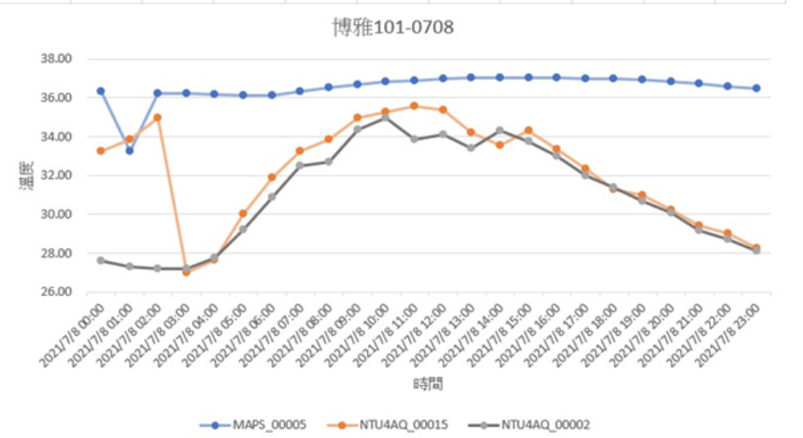 | 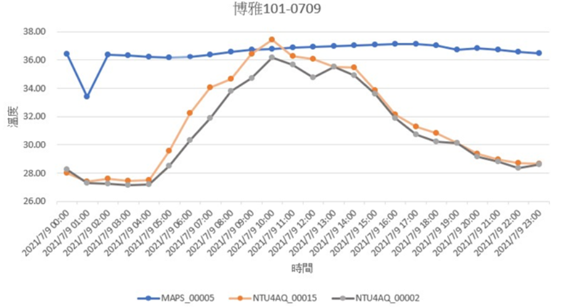
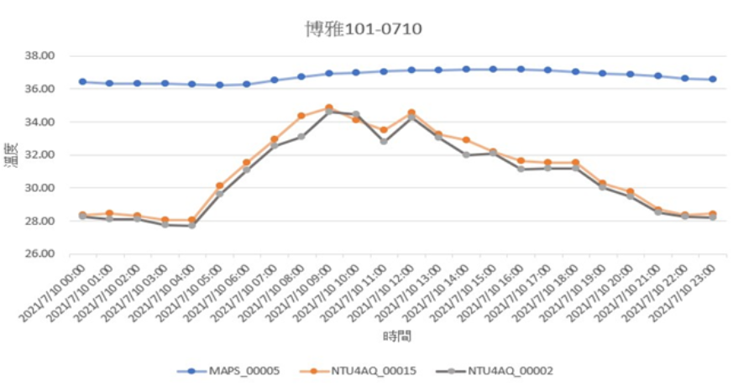 | 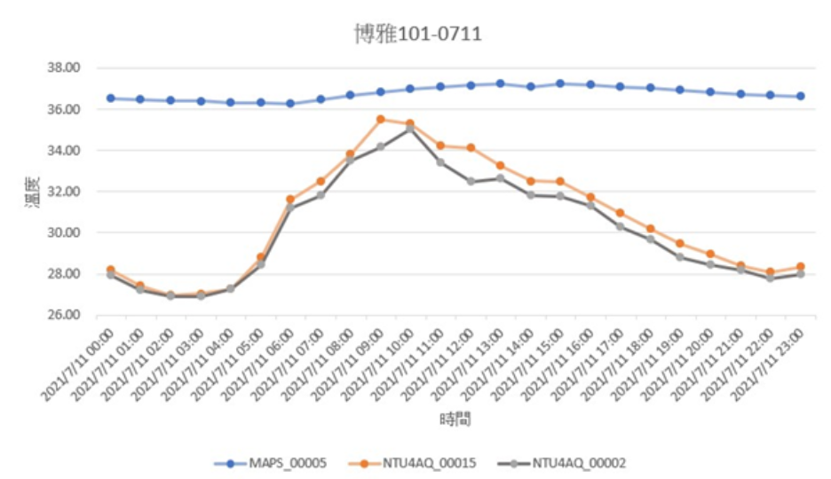
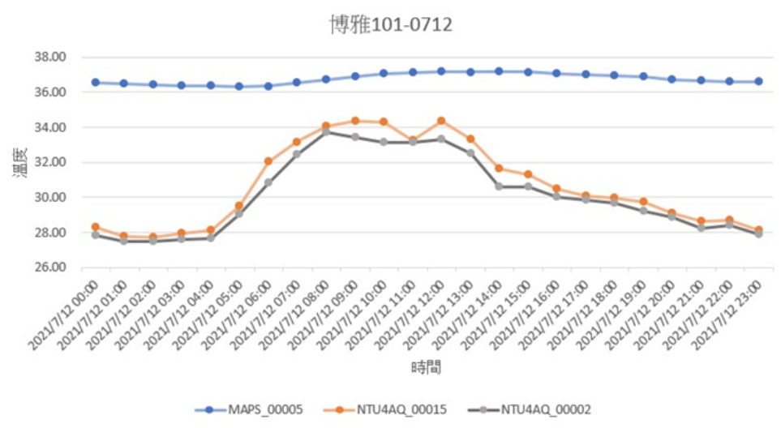 | 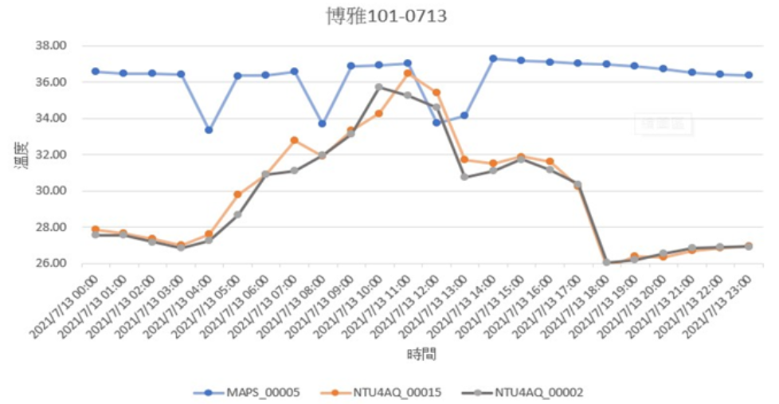
- 運用CEB Thermal Comfort Tool找出符合博雅101教室的舒適度區間:
1.CEB Thermal Comfort Tool有多項功能，其中我是採用ASHRAE-55 選擇PMV的方法去進行觀察，空氣線圖顯示出來的是操作溫度以及濕度之間的關係，空氣線圖中紅點為自行輸入的參數，藍色區域為舒適度區間。主要我想觀察的部分在博雅101教室中我所輸入一周的參數進入ASHRAE-55當中，了解PMV數值以及這一周時間的溫度是否在舒適度區間中。
2.影響PMV(預測平均表決)指標的因素包含室內環境因素( 乾球溫度、相對濕度、黑球溫度(平均輻射溫度)、 乾球溫度、風速)以及人體因素(衣著量、活動量)
PMV指標將熱舒適程度分為七個階段
PMV 指標值 | 舒適度感受
3 | 炎熱Hot
2 | 溫暖Warm
1 | 微溫Slightly warm
0 | 適中Neutral
-1 | 微冷Slightly cold
-2 | 涼爽Cool
-3 | 寒冷Cold
備註:人體感到舒適的範圍介於-0.5與+0.5之間

07/08-07/13帶入CEB Thermal Comfort Tool 的參數
MAPS_00005  10:00AM | 07/08 | 07/09 | 07/10 | 07/11 | 07/12 | 07/13
Operative Temperature (°C) | 36.81 | 36.79 | 36.93 | 36.65 | 37.05 | 36.92
Air speed(m/s) | 0.15 | 0.15 | 0.15 | 0.15 | 0.15 | 0.15
Relative Humidity (%) | 54.46 | 54.38 | 54.57 | 54.93 | 55.19 | 54.92
Metabolic Rate (%) | 1.2 | 1.2 | 1.2 | 1.2 | 1.2 | 1.2
ClothingLevel(clo) | 0.6 | 0.6 | 0.6 | 0.6 | 0.6 | 0.6

正常舒適範圍內
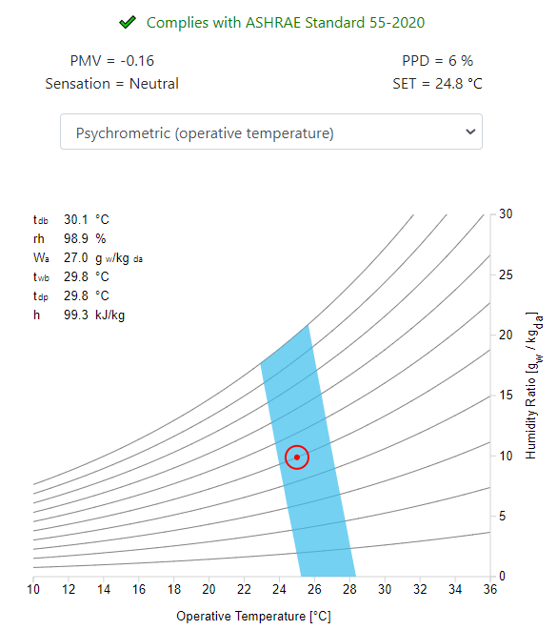
07/08 | 07/09
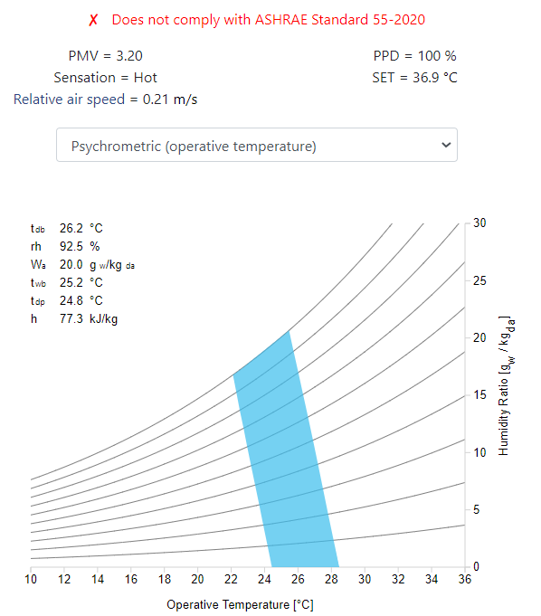 | 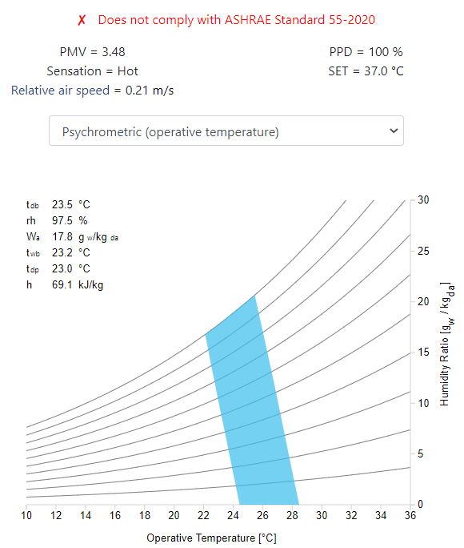
07/10 | 07/11
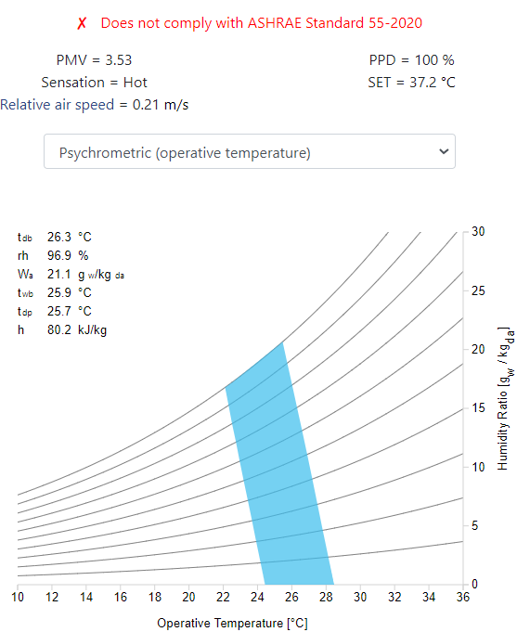 | 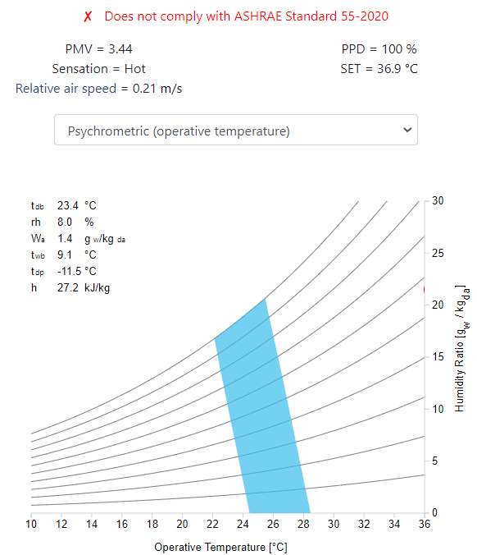
07/12 | 07/13
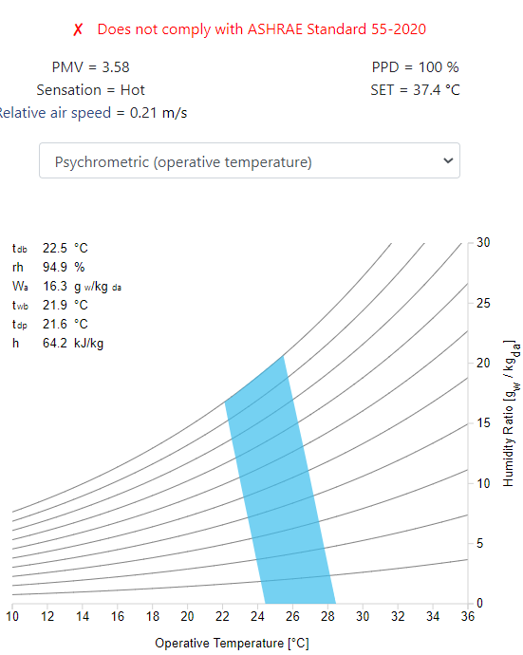 | 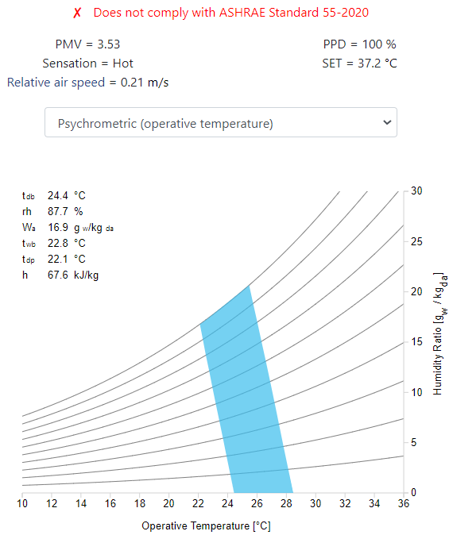

07/08-07/13(非上課期間PMV數值的變化)
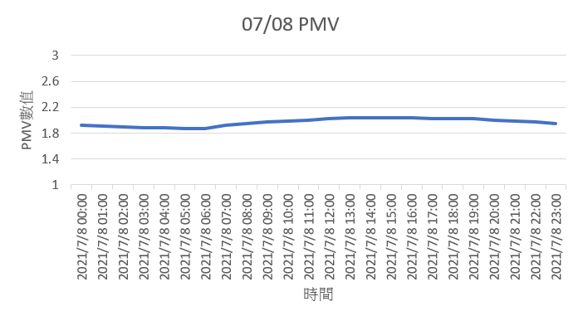 | 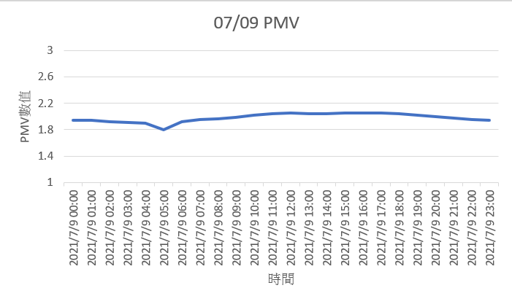
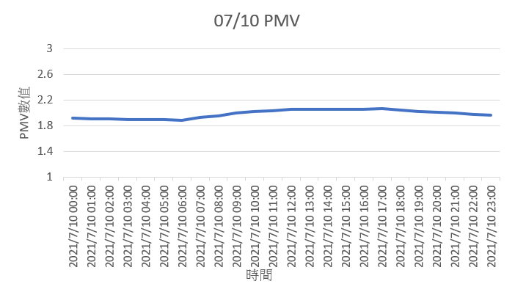 | 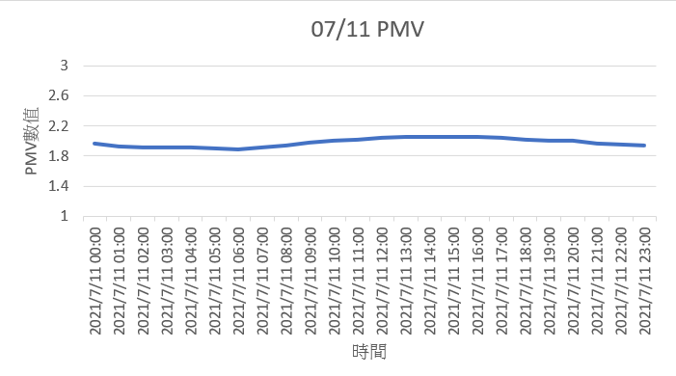
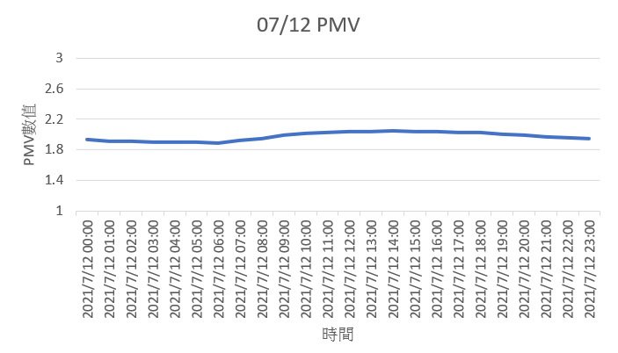 | 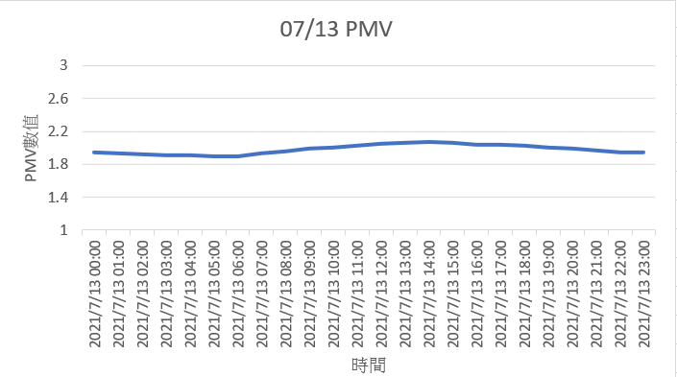

參考資料
●綠建築解說與評估手冊 內政部建築研究所●參考文獻:依據熱舒適模型之空調節能控制技術https://km.twenergy.org.tw/KnowledgeFree/knowledge_more?id=4597
●參考文獻:複合式通風應用於臺灣潛力分析之研究https://ws.moi.gov.tw/Download.ashx?u=LzAwMS9VcGxvYWQvT2xkRmlsZV9BYnJpX0dvdi9yZXNlYXJjaC8xNzg4LzE0NDc5MzAwNDcxLnBkZg%3D%3D&n=Y29tcGxldGUucGRm
●參考文獻:室內舒適度指標:http://www.hvac-net.org.tw/CKEdit/upload/files/室內舒適度指標.pdf
●CEB Thermal Comfort Toolhttps://comfort.cbe.berkeley.edu/
報告內容:
Good morning teachers
Today I am share my Report made during the summer vacation.
And my topic is
P.2 TOPIC: Discussion on indoor air quality improvement measures and the model of buildings energy consumption time.
1. 目前沒有人使用這個教室，如果沒有人使用，溫度會隨著室外溫度而變化。原因是教室有室外窗戶，室外的熱量會通過室外窗戶慢慢帶進房間。此時，夏季氣溫會因室外溫度的影響，導致室內溫度緩慢上升。 （但變化不大，因為沒人用這個教室）
2、室外溫度升高，室內溫度也升高。 我想建立兩者之間的關係。(1) 教室的溫度會隨著室外溫度的變化而變化(2)當室內溫度升高時，室內製冷量會消耗更多的能量來降低室內溫度 (3) 當有人進入這個教室時，理論上溫度上升得更快（原因：人體溫度、室內電腦使用等）
Indoor comfort (Discuss 博雅101教室)
And l use the
Instrument:
Outdoor:NTU4AQ_00002、NTU4AQ_00015、Indoor:MAPS_00005
Here is the
Situation:
1. At present, no one is using this classroom, and the temperature will change with the outdoor temperature if no one is using it.
The reason is that the classroom has outdoor windows, and the outdoor heat will be slowly brought into the room through the outdoor windows.
At this time, the temperature in summer will cause the indoor temperature to rise slowly due to the influence of the outdoor temperature. (But the change is not large, because no one is using this classroom)
2. When the outdoor temperature rises, the indoor temperature also rises. I want to establish a relationship between the two.
(1) The temperature of the classroom will change with the outdoor temperature
(2) When the indoor temperature rises, the indoor cooling capacity will consume more energy to reduce the indoor temperature
(3) When someone enters this classroom, theoretically the temperature rises faster (Reason: human body temperature, indoor computer use, etc.)
P.3這裡是我所繪製三台儀器的溫度與時間的變化，這是7月8號到7月13號一週的變化，是沒有人使用這間教室的狀態，不過藍色線所代表的maps5儀器，很明顯的溫度是保持很高的狀態，
因此我想要試著繪製maps5儀器所測出的溫度與濕度的數值帶入空氣線圖中。後面的簡報會進行介紹。
P.3
Here is the temperature and time changes of the three instruments I have drawn. This is the week from July 8th to July 13th. No one is using this classroom. However, the blue line represents the maps5 instrument. Obviously the temperature is kept high,
So I want to try to draw the temperature and humidity values measured by the maps5 instrument into the Psychrometric chart.
P.4
這裡是熱舒適模型的一篇文獻中，簡單介紹
ASHRAE 目前使用新的有效溫度 (ET*) 作為人體熱舒適評估指標。該指數考慮五個參數：溫度 (℃)、濕度 (%)、風速 (m/s)、衣物量 (clo) 和活動水平 (met)。 在風速、衣物量和活動量相同的情況下，相同的新有效溫度會有相同的冷熱感覺。而右邊這張圖片，圖中所圍出來的區域就是舒適度的區域，然後我想使用這張圖的概念去將maps5儀器的五項參數帶入進去，繪製操作溫度與濕度之間的關係。
P.4Here is a brief introduction to the thermal comfort model
ASHRAE currently uses the new effective temperature (ET*) as an indicator of human thermal comfort. The index considers five parameters: temperature (°C), humidity (%), wind speed (m/s), clothing volume (clo) and activity level (met).
In the case of the same wind speed, amount of clothing and activity, the same new effective temperature will have the same feeling of cold and heat.
In the picture on the right, the area enclosed in the picture is the comfort zone.
Then I want to use the concept of this picture to bring in the five parameters of the maps5 instrument to plot the relationship between operating temperature and humidity.
P.5
這裡就是CEB Thermal comfort tool的操作介面，我想要去繪製右圖的空氣線圖，而我所選用的就是紅色箭頭所指示的ASHRAE-55的形式，要盡可能的將圖形滿足紅色匡線裡面所勾選出來的complies with ASHRAE standard 55-2000的狀態，也就是圖中紅色點要在藍色的舒適區域中，才可以符合舒適度。
P.5
This is the operation interface of CEB Thermal comfort tool. I want to draw the Psychrometric chart on the right.
And what I chose is the ASHRAE-55 form indicated by the red arrow, which must meet the state of the Psychrometric chart, which is selected in the red line of complies with ASHRAE standard 55-2020.
That is, the red point in the figure must be in the blue comfort zone to meet the comfort level.
P.6
ASHRAE 55:**將熱舒適性定義為“對熱環境表示滿意的心理狀態”，主要在美國使用，但作為設計、調試和測試室內空間和系統的標準。
ASHRAE 55 的範圍:
(1)主要針對居住者處於久坐狀態（即辦公室工作）的空間中的熱舒適性而設計。
(2)考慮的六個環境和個人因素是溫度、熱輻射、濕度、空速、活動水平（代謝率）和人員著裝（絕緣程度）。
(3)未考慮空氣質量、聲學、照明或污染等因素
CEB Thermal Comfort Tool - ASHRAE 55
ASHRAE 55: Defines thermal comfort as "a mental state of satisfaction with the thermal environment", mainly used in the United States, but as a standard for designing and testing indoor spaces and systems.
Range of ASHRAE 55:
(1)It is mainly designed for thermal comfort in the space where the occupants are in a sedentary state (ie office work).
(2) The six environmental and personal factors considered are temperature, heat radiation, humidity, airspeed, activity level (metabolic rate) and personnel clothing (degree of insulation).
(3) Factors such as air quality, acoustics, lighting or pollution are not considered
How to meet ASHRAE Standard 55?
(1)If at least 80% of the occupants are not expected to object to environmental conditions, the comfort zone is considered comfortable enough, which means that most people are between -0.5 and 0.5 on the PMV level.
(2)In order to comply with ASHRAE55, the factors that need to be considered include natural ventilation systems, mechanical ventilation systems, all expected conditions (including summer and winter, but not extreme conditions), and finally external and internal environmental factors also need to be taken into consideration.
P.7
所需的熱舒適條件 ASHRAE 要求的條件必須包括以下所有條件，自然通風和空間除外：
(1) 設計工作溫度、濕度和室內總負荷。
(2) 與室外天氣百分比設計條件相關的每個季節性超額小時數。
(3)局部不適效應（即如果有人坐在散熱器旁邊或直接在散熱口的正下方，即使整個空間整體處於熱平衡狀態，也可能引起局部不適。
P.7
Required thermal comfort conditions The conditions required by ASHRAE must include all of the following, except for natural ventilation and space:
(1) Design working temperature, humidity and total indoor load.
(2) The number of hours of each seasonal excess in relation to the outdoor weather percentage design conditions.
(3) Local discomfort effect (that is, if someone sits next to the radiator or directly under the cooling vent, this may cause local discomfort, even though the entire space is in thermal equilibrium as a whole.
P.8
這裡就是延續文獻中臺灣的舒適度區域，我想要先將數值帶入到CEB Thermal comfort tool中去觀察他的舒適度區域，
左邊紅色箭頭指示的地方就是CEB Thermal comfort tool選用的ASHRAE-55的版本，左側的輸入方法選用PMV method，而依序帶入上一頁所說的臺灣舒適區域的數值。
P.8 This is the comfort zone of Taiwan. First I want to bring the value into the CEB thermal comfort tool to observe the comfort zone.
The version of ASHRAE-55 selected by the thermal comfort tool at the place indicated by the red arrow. The input method to the left selects the PMV method. And bring in the value of Taiwan's comfort zone mentioned on the previous page.
P.9左圖的的樣子，可以看到在正常的情況下，是滿足舒適度的區間，且pmv 的值介在微冷以及適中的範圍內，sensation感覺（感知）也是達到neutral自然的狀態。
接下來看到右下角的空氣線圖，可以在紅色匡線中看到，最上面紅色顯示Does not comply with ASHRAE Stardard 55-2020，如果看到這樣的顯示表示我所帶入的參數中是不滿足舒適度區間的。
而上方的這個表格，是我想把這些參數帶進CEB thermal comfort tool中去進行觀察，紀錄的時間單位也是使用一週到時間去繪製，然後空氣速度、代謝率以及衣著量是沒有改變，有變化的數值是操作溫度跟濕度。
P.9
In the picture on the left, we can see that under normal circumstances, it is the interval that satisfies the comfort level.
And the value of pmv is in the range of slightly cold and neutral, and the sensation feels that it has reached to natural state.
Next, when we see the psychrometric chart in the lower right corner, you can see,
The red at the top shows Does not comply with ASHRAE Stardard 55-2020, which means that the parameters I have brought in do not meet the comfort zone.
And the above table is that I want to bring these parameters into the CEB thermal comfort tool for observation.
The time unit of the record is also drawn using one week to the time, and then the air speed, metabolic rate, and amount of clothing have not changed. The values that have changed are the operating temperature and humidity.
P.10
我帶入了前一頁表格中的每一項數值得到的空氣線圖，不過我不太確定我這樣繪製是否正確，可能還存在問題，因為這幾張圖都顯示不舒適，且PMV的值高達3.2，代表舒適度的感受程度是炎熱的狀態。
P.10
I have brought in the psychrometric chart obtained from each value in the table on the previous page, but I am not sure whether I am drawing it this way, there may be problems, because these charts are uncomfortable, and the value of PMV is as high as 3.2, the degree of comfort that represents the hot state.
P.11
而老師後來提供我另一個方法去進行觀察，看能否改善上述不太確定是否準確的空氣線圖，也是在CEB thermal comfort 中去upload我所有已知的參數，選擇pmv 的模式去上傳資料，也同樣是在CEB thermal comfort tool去進行上傳，最後上傳完資料，會產生一個excel檔。
P.11
And the teacher later offered me another way to observe.Also upload all my known parameters in CEB thermal comfort.
Choose the mode of pmv to upload the data.
Finally, uploading the data, an excel file will be generated.
P.12
上傳的資料時間一樣是一週，不過可以看出數值是符合pmv的舒適範圍內，pmv數值的幅度變化沒有很大，pmv 數值介在1.8到2.07之間。
P.12
The uploaded data time is the same ,but it can be seen that the value is between the comfortable range of pmv, the magnitude of the pmv value does not change much, and the pmv value is between 1.8 to 2.07.
P.13
根據上一頁的圖，所得到的數值。PMV的數值是介在1.8到2.07之間，對應到PMV指標的熱舒適程度7 個階段的表格中得到的舒適度感受程度介在微溫以及溫暖之間。我自己覺得透過CEB thermal comfort tool 上傳這筆資料在繪製出來的圖形較為準確。這裡就是我的報告，報告到此結束，謝謝各位老師的聆聽
According to the figure on the previous page, the value obtained. The value of PMV is between 1.8 to 2.07, and the comfort level obtained in the 7-stage table corresponding to the thermal comfort level of the PMV index is between low temperature and warmth. I personally think that the graphics drawn by uploading this data through the CEB thermal comfort tool are more correct.
It is the end of my presentation. Thanks for listening.

